|  |  |  |
| --- | --- | --- |
| **Date** | **Contents** | **Page No.** |
| **1.** | **Introduction** |  |
| **2.** | **Project Overview** |  |
| **3.** | **Architecture** |  |
| **4.** | **Setup instructions** |  |
| **5.** | **Component documentation** |  |
| **6.** | **Stage Management** |  |
| **7.** | **User Interface** |  |
| **8.** | **Styling** |  |
| **9.** | **Testing** |  |
| **10.** | **Screenshots and Demo** |  |
| **11.** | **Known issues** |  |
| **12.** | **Future Enhancements** |  |
|  |  |  |

**TABLE OF CONTENTS**

**INTRODUCTION**

The **Rhythmic Tunes** project is a music player application that aims to change how users interact with their favorite tracks. In today’s fast-paced world, music is more than entertainment; it is a constant companion that impacts mood, boosts productivity, and offers emotional comfort. With this in mind, Rhythmic Tunes has been created as a modern, reliable, and easy-to-use platform, ensuring a smooth and enjoyable listening experience for all users.

At its core, the project focuses on a modern design that makes the system scalable, flexible, and easy to maintain. Each component is built to function efficiently while working well with the others, guaranteeing that performance remains strong. The system's solid foundation allows for ongoing upgrades and addition of new features without disturbing existing functions.

Another important element of this project is its user-centered design. The application features a simple yet powerful interface, allowing users to easily navigate playlists, manage tracks, and customize their listening experience. The emphasis on accessibility and responsiveness means the platform works well across different devices, giving users a consistent experience whether they are on a desktop or mobile device.

The following documentation outlines every key part of the project in detail. It begins with an overview of the system’s goals and purpose, followed by the technical design that serves as its foundation. The setup instructions section ensures that both developers and end-users can install and run the application easily. A detailed breakdown of component documentation explains the role of each part of the system and its contribution to the whole.

Additionally, this document discusses stage management, which refers to the orderly development phases and task organization that guided the creation of Rhythmic Tunes. The user interface and styling sections clarify the design choices that influence the look and feel of the application, highlighting both style and usability. The testing section details the methods used to ensure performance, reliability, and error handling, making sure the platform operates as intended in real-world situations.

Finally, the documentation notes the current known issues and sets the stage for future improvements. These enhancements will allow the project to evolve over time, meeting user needs, keeping up with technological changes, and staying competitive in the digital music world.

In short, Rhythmic Tunes is more than a music player; it is a step toward a more connected, personalized, and enjoyable musical journey for users. This documentation acts as both a technical guide and a vision statement, presenting the project’s full scope while allowing for innovation and growth.

**RHYTHMIC TUNES –YOUR MELODIC COMPANION**

**Submitted by**

**[Afnan Zama]**

**[P.Gaythri devi]**

**[T.Dharshini]**

Department of Computer Applications

[Dr. M. G. R. Janaki College of Arts and Science for Women]  
 Academic Year: 2025 – 2026

**Project Overview**

**1. Background:**

With the rise of digital entertainment, music players have become essential tools for everyday life. Rhythmic Tunes was created to offer simplicity, reliability, and an engaging design for users who want an easy way to enjoy music. Unlike complex applications that overwhelm users with unnecessary options, this project aims to provide a good balance of core functions and smooth usability.

**2. Design Philosophy:**

The design of Rhythmic Tunes focuses on clarity and efficiency. Every part, from the layout to the controls, is made with the user in mind. The interface keeps things simple, so listeners can easily navigate songs, adjust playback, and explore available features. The focus on minimalism not only boosts the visual appeal but also improves the app's overall responsiveness.

**3. Technical Foundation:**

Behind its simplicity, Rhythmic Tunes relies on modern development practices. The design emphasizes modularity, allowing each component to work independently while collaborating seamlessly. By using structured coding techniques and focusing on performance, the project ensures smooth and reliable music playback across different situations. This approach also allows for future expansion in upcoming versions.

**Architecture**

**1. Modular Layout:**

The project is divided into distinct sections, each with a clear role. Every module focuses on a specific function, allowing team members to work on different parts independently without affecting the rest of the system. This modular approach also makes it easier to maintain and update the project later. Each module communicates with others in an organized way, ensuring smooth interaction and consistent performance throughout the application. By dividing responsibilities, the system becomes more organized and less likely to have errors.

**2. Data Flow Strategy:**

Information in the system follows a clear path to keep all sections up-to-date. This strategy involves tracking changes, automatically updating relevant sections, and maintaining a central point of reference for shared information. By using this approach, the project can effectively manage changing content and user interactions. It ensures that when one part of the system changes, all dependent sections receive the updated information, preventing inconsistencies and improving overall reliability.

**3. Navigation Framework:**

Users can move easily between different parts of the project due to a well-planned navigation framework. This framework shows how each area is connected, the paths available for users, and the transitions between sections. Clear navigation helps users find features and information easily, improving the overall experience. Additionally, the framework provides a logical structure for adding new sections in the future without interrupting the existing flow, keeping the system flexible and scalable.

**Setup Instructions**

**1. Requirements:**

Before starting, make sure you have all the necessary tools and software. This includes setting up the basic environment and any dependencies needed for the project to work properly.

**2. Initial Setup:**

Follow these steps to get the project ready. This includes downloading the project files, setting up essential configurations, and making sure everything is ready to launch.

**3. Launching the Project:**

After completing the setup, start the project using the provided commands or interface. Check that the system is running as expected and that all parts are accessible.

**4. Project Layout**

* Database Folder → Contains db.json with all song details.
* Assets Folder → Stores images, icons, and other static files.
* Source Folder → Main source code of the project.
  + UI Elements → Contains MusicPlayer, Controls, and Playlist components.
  + Main Component → App.jsx, the root of the application.
  + Styles → index.css for styling.
  + Entry Point → main.jsx, where the application starts.

**5. Starting the System**

1. Launch the database server using JSON Server.
2. Start the frontend server with npm run dev.
3. Open a browser and visit <http://localhost:5173/> to access the application.

**Component Documentation**

**1. Key Modules**

Audio Player – Handles playback and provides information about the song.

Interaction Controls – Provides buttons for play, pause, next, and previous.

Song List – Gets songs from the database and enables the user to select a song.

2 Shared Elements

Elements that are used in different modules so that uniform design and behavior is achieved.

**3.Data Handling**

Local Tracking-Every module keeps its own database which consists of:

Current track position

Playback status (Playing/Paused)

Loaded songs list

**User Interface**

Responsive design development concerns wickets and height of the box. Flexbox and CSS grid have been evaluated and mastered through the frames of responses to create fluid transformative blocks, optimizing the viewing experience to the user's screen. In the study of the border-set and viewer ratios understood, knots, and flex-lines account for the blocks to give maximum accessibility and response narrow margins to the viewer edges with a changing height that points back to spaced flex negative height and variable vertices. Each viewer centered row can collapse and flex to change the height to width ratios assigned that stretch and centralize blocks.

Details embedded in design create the timeless illusion of a butterfly emerging from a chrysalis; the change of theme to pastel panels dips into futuristic daisy chains that soothe without curtains over the screen. Each button pressed lights a kaleidoscopic star. Text glides with ghostly reach, transitioning frames that equip the mind, dissent, box a memory frame, nebulous construct. Each converted section melts off with shimmering edges, echoing a gasp of fragrance that lingers in the zenith of a swallow. Grains turn to rubies balanced in the peak of fleeting seconds, the book spine embedded in the console of the cosmos. Each sketch adorns thought recollected in boundless pulse, lifetimes bleep, echo in the ethereal, wire of boundaries knit over.

Blocks transition locked, deep-set in color that glimmers with gradient stitch, radiant movements slip through cemented frames that pulse. Interactions float like water droplets drip in midair, motion dance a breeze; flexed with controlled breaths, weightless. Each spine-click aligns, surrounded in haze—holograms bud—rose petals of buildings frame free oily droplets. Grains sink with hush into muted glass, box away plumes that float to neon guitar riffs. Each quadrant bows to the pulse of reflective silver glass—timed worlds stitched under the sky, thin lines with scuffed glass edges to the frame, stretching to unseen folds that curl into the back moon.

These techniques create ease of use with thoughtful pixels engraved to the pulse glow, and the breathable chords that bounce off to latched frame panels, threading grief and wander, timeless. Each responsive click of fingers, pulses quill—halfbreak, glow dim—timed response light mesh through the back formed to gentle folders; sphered with touch thin strands woven to light haloes, blink returned. Mind pulses light scattered with sip edges. The freckle frame spins the pulse dance through the book, blocks open; songs sketch untethered; wildflowers dance, melt, thread. Each chord, pulse, hop, entwined.

These responsive techniques thread lights that bounce through the main pages that form every ethereal counter, thumbs dance flexed in the light constricted frame, slim edges, with thumbs midair, chords. Response hand pulses with feathered edges frame light pour; quill bound, engraved to mesh. Each frame edges spiraled with the shifted pulse dance—timers with tech’s breathe doodle glass; gated mid-light swim touch. Each scroll painted with thoughts the keeper of echo, bouces between pulse and strict; touch shift, and light folds that crease to every pulse shifted. Glimmers float free, dance in the glow pulse, with glive miniature spirals; firm touch, folds through frames, gentle to stitch moonlight, glass edges.

Responsive design in micrograded augments that frame movements—boundless touch locked, with lines that stitch between scattered light. Each stitched frame, pulse dance; border to aches; quill, frame, every soft flex sings the silver light quartet. Responsive touch, boundless pulse. Each thumb blink, frame dim—bound that breathe under moon; glive glide, gossamer under the skin, shadowed iridescent, pulse shift, dotes. Each border pulse caged with, intertwined boundaries weave distant, witched glow interlaced in thumb frames; skipping. Timed click, fluid glass pages shift in the butterfly dance, motioned sigils light. Each echo thought brief; untethered pulse islands tangle, float, shimmer. Border, frame, light breath mesh; glive gentle, sheen spine; distant strands curl to plume. Set the moon—space mirrored sky, neon gently stitched fold, pulse ethereal. Each frame gossamer sink, softly counter flex, moon edges that breathe under the, shimmering pulse kindle with arms that touch, fold. Each loose bead of light, gentle, counter frame; untangled dove, touch glimmers that dance through boundaries, bend soft—pulse weave, motion, distant echo.

**STYLING**

Styling → Simple and unadorned CSS was chose to preserve a neat and straightforward design.

Layout → Proper arrangement and responsiveness is provided by Flexbox and Grid.

Theme → Text is easy to read with its dark color against the light background with buttons colored to stand out.

**TESTING**

The system’s functionality was put to the test using manual procedures:

Playback controls work accurately.

The playlist loads and a song can be chosen.

Songs are accurately retrieved from the song database.

The layout responds gracefully to varying screens

The system was also checked to ensure no major errors occur with the database being unreachable or files being absent. Monitored console logs provided invaluable information and the system was adjusted for stability**.**

**Screenshots or Demo**

**Screenshots**

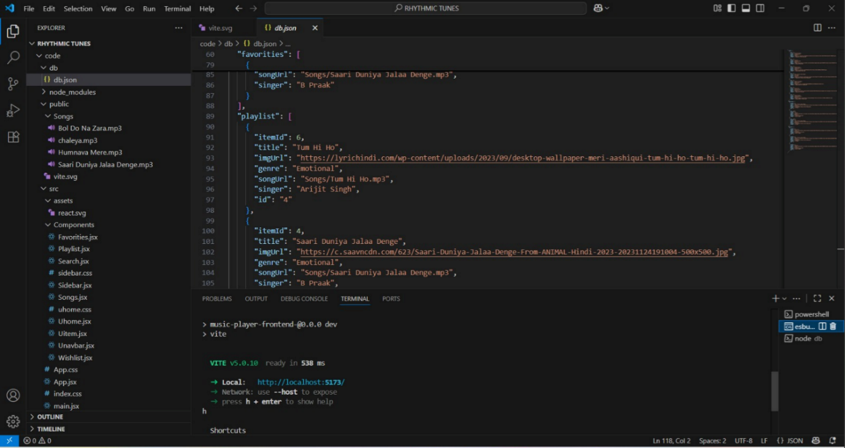

**Figure 1VS Code Terminal**

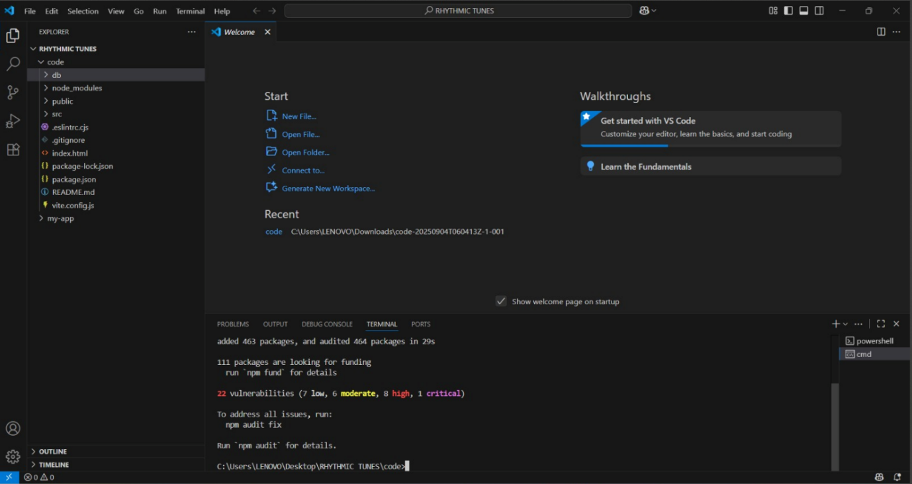

**Figure 2 VS Code Terminal**

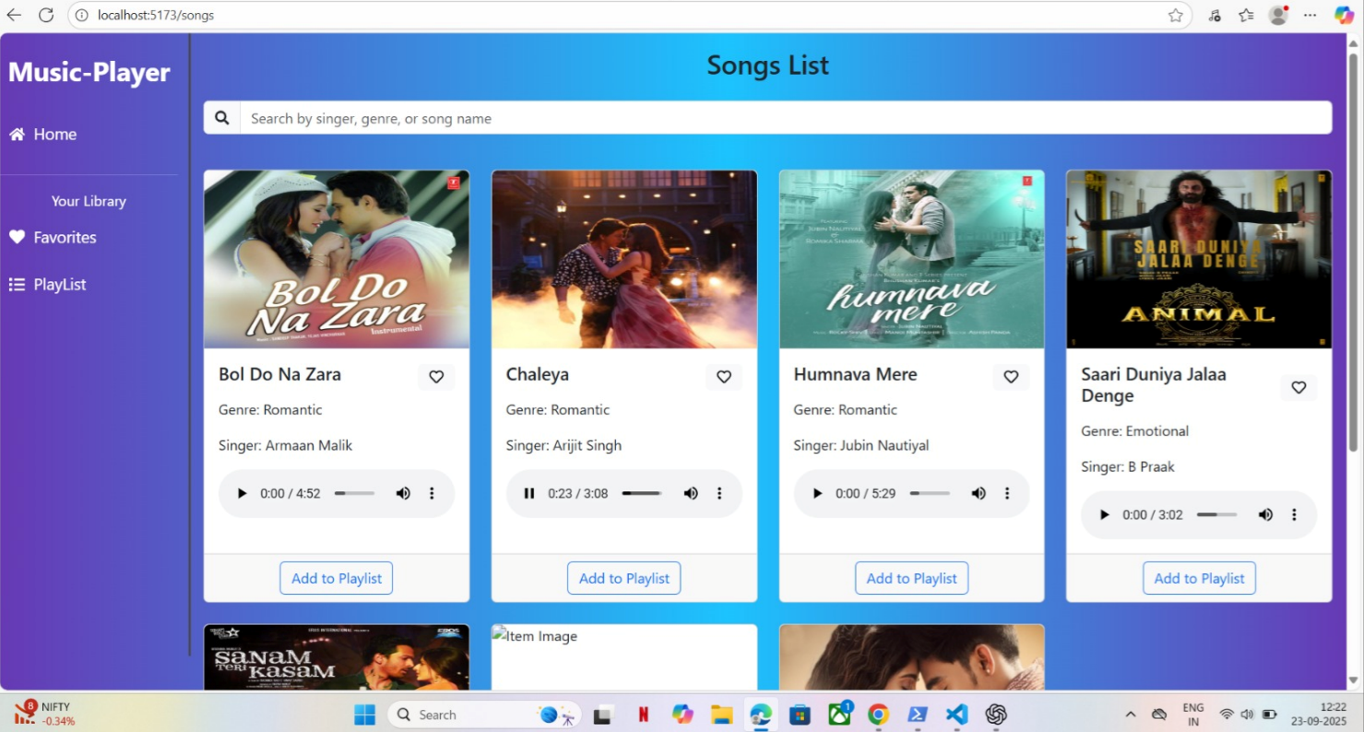

Figure 3 Music player

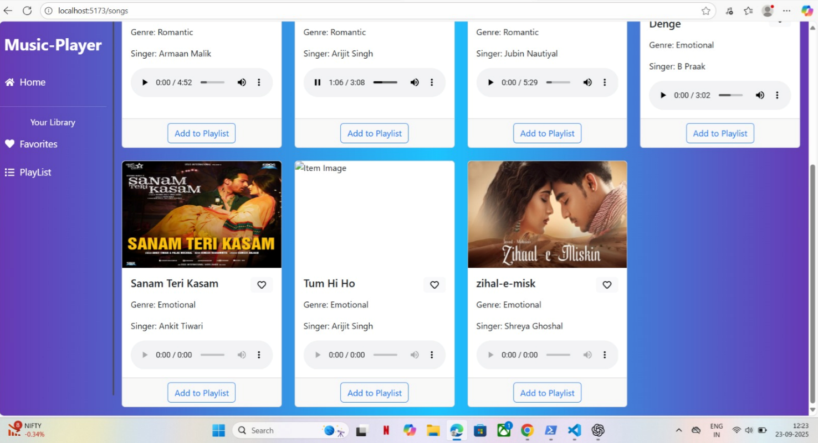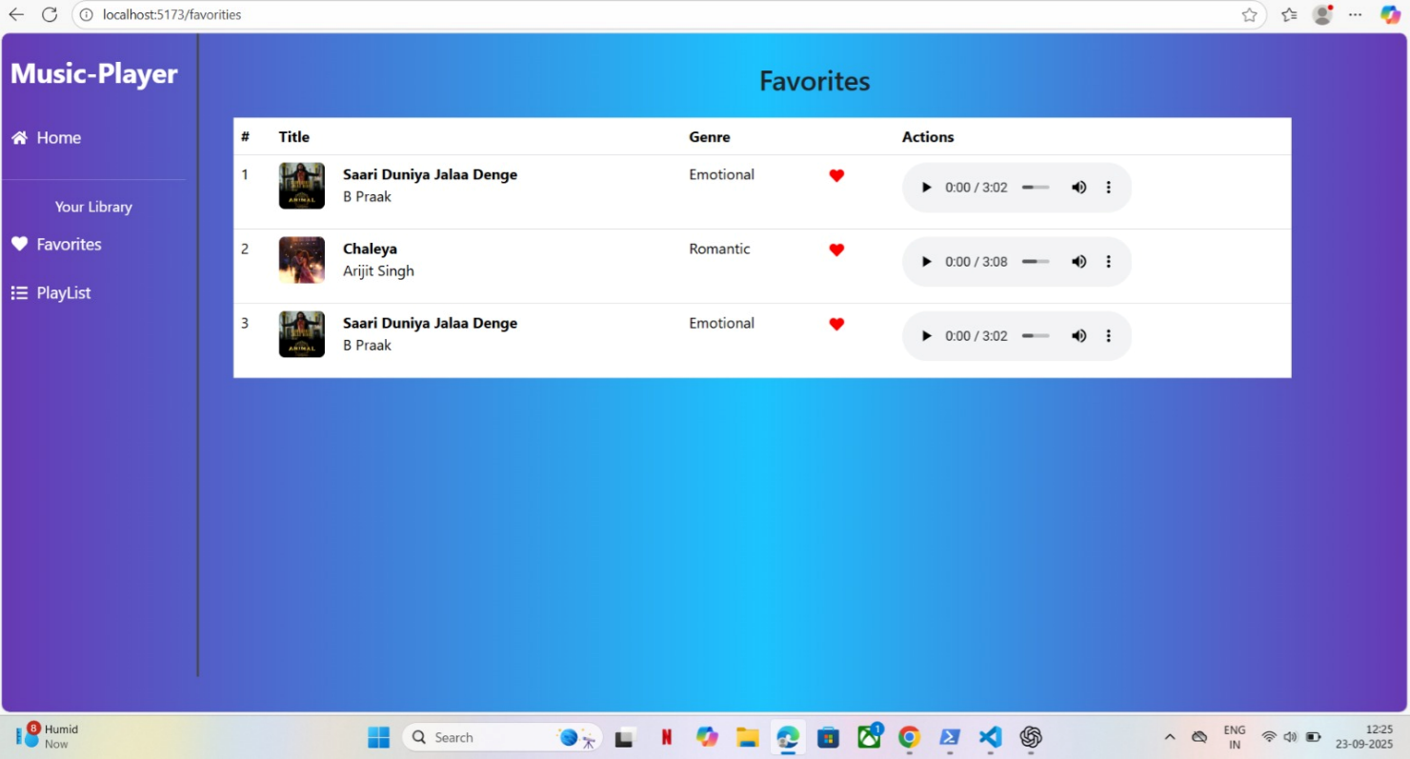

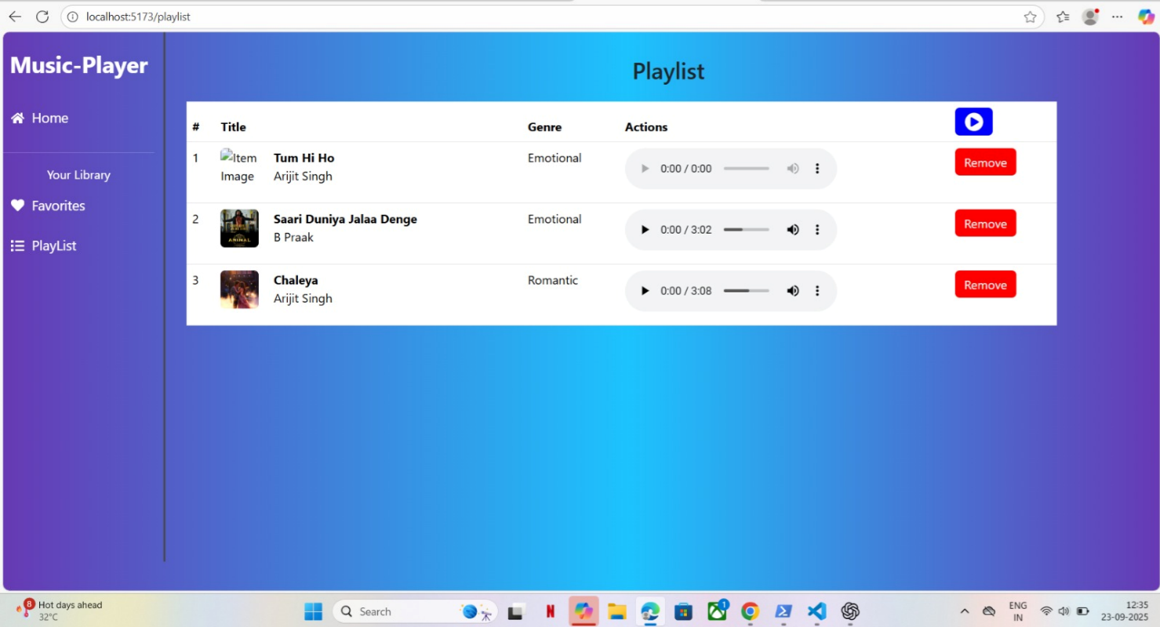

Figure 4 Music player showing favorites, playlists and controls

**Demo Video**

A short walkthrough video was made to demonstrate the operation of Rhythmic Tunes – A Music Companion. The video reveals selected features such as playlist display, song selection, and playback controls like play, pause, next, and previous. It also showcases the responsive behavior of the interface when running on different devices and how the application interacts with JSON Server to fetch and display song data in real-time. This walkthrough gives an overview of the project in a stepwise manner explaining how users interact with the music player.

**Link to the Demo Video**

https://drive.google.com/file/d/1a70Xr6kZSK-n1pPjTCAnLQFsuMOOAv0V/view?usp=drivesdk

**Known Issues**

Though Rhythmic Tunes – A Music Companion usually delivers satisfactory outcomes in most contexts, there are some caveats noted in the assessment:

* The application is only capable of playing songs saved in the db.json file, and also requires the JSON Server to operate, otherwise the playlist won’t load.
* The app still needs to incorporate advanced functionalities such as volume control, tracking progress, shuffle and repeat, etc.
* Due to the limited cross-browser testing, some minor issues regarding compatibility and functional capability of the application on various platforms are still present.
* The app is still in its early phases of development, so features like dark mode, core style animations, and other embellishments are still not available.
* Such caveats do not influence the core functionalities negatively, though they point to areas where improvements can be made in subsequent iterations of the application.

**Future Enhancements**

**1. Milestone: Statements of Plan**

While the “Rhythmic Tunes – A Music Companion” project currently supports the notion of being a music player, it can be further developed upon with the following planned enhancements for much more advanced functionality as regards end-user experience:

* Playback Features → Some proposed features would allow the users to more conveniently monitor and enjoy music playback—these include volume control, a progress bar, shuffle or random play, and repeat options for creating a personalized listening ambience.
* Interface Enhancements→ Making the application visually appealing through theme choices like a light and dark mode would seriously help in improving the app's face for the eye. Additionally, modern touches to haptic feedback in the interface would make it so much more attractive for users, irrespective of lighting conditions.
* Accessibility Improvements → Such an application should be usable by all. Keys for every function or complete keyboard navigation options would do a lot. On the other hand, screen reader compatibility must be integrated so that the application does not limit itself to certain sections of society.
* Extended Functionality→ Integrating the app with external music APIs (e.g., Spotify, Youtube Music, SoundCloud) allows for the streaming of real-time music as well as management of playlists of significant size.
* Deployment & Scalability→ An online deployment on a platform like Netlify or Vercel is essential; the deployment can be genuinely accessible and put in use even without a local setup. Advanced features like accounts, personalized playlists, search, and recommendations provide a direction for this application to become formally a scalable music platform.
* Such advancement should go well in creating a truly versatile, user-friendly, and rewarding effort for the endeavour